## **USER MANUAL / USER GUIDE**

This manual provides information about the steps necessary for users to use the Asset Banking App. The Asset Banking app is a Progressive Web App that gives users an experience that is similar to a native app. The installation and use of the Asset Banking app is quite simple and it will be described in the steps below.

**USER INSTALLATION**

How to download the Application on Mobile devices:

To download the application directly from the Asset Banking App web page, heed the following steps.

1. Use the link <https://banking-app-e435f.web.app/welcome> to access the Asset Mobile Banking app.
2. Click on the little Asset Mobile icon located at the top right hand corner of the screen to download and automatically install the app.

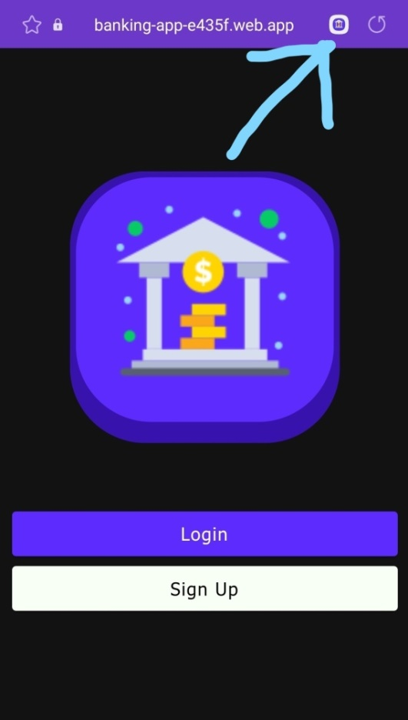 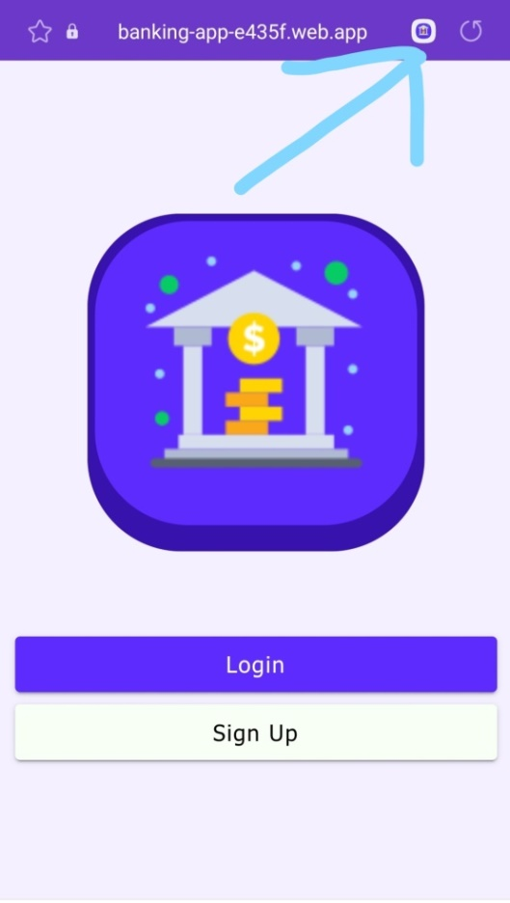

Fig. 10: Index page of the Asset Banking app with Dark (left) and Light mode (right)

**USER SIGN UP**

How to sign up on Mobile devices:

As a first-time user, additional steps must be completed before gaining access to your account and application. To sign up on the Asset Banking App, take the following steps.

* On your mobile device, launch the application.
* Click on the SIGN UP option on the page.
* Complete all required fields and tap sign up
* If the system accepts the information provided, the home page will appear as your information loads.

NOTE: You can only sign up when you do not have an existing account. To access your account after sign up, you must LOG IN.

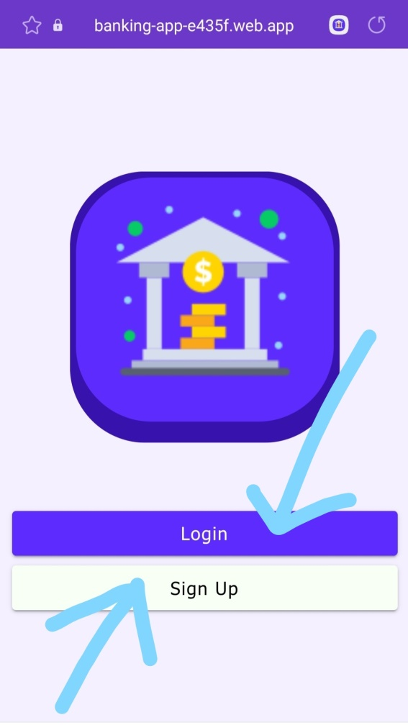

Fig. 11: Index page of the Asset Banking app showing the LOGIN and SIGN UP buttons

**USER LOG IN**

How to LOG IN on Mobile devices:

After downloading the application and completing SIGN UP, the user is now ready to log into their account.

* On your mobile device, launch the application.
* Enter the valid email and password used to register during the SIGN UP process and tap LOG IN. If the information provided is correct, the home page will appear as the user’s information loads.

NOTE: If the information is not correct a voice assistant will indicate that the information is not correct and you would need to click on the SIGN UP option to create a new account.

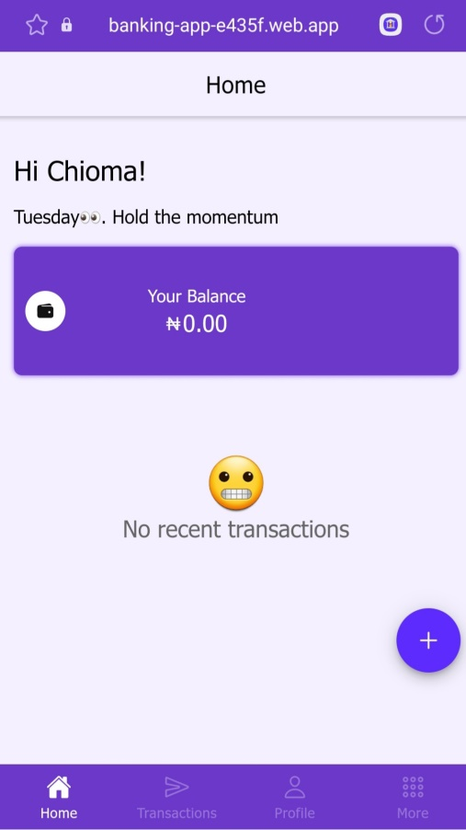

Fig. 12: Home page of the Asset Banking app showing the (test) user information

The home page after log in and the home page displays information such as the user name, the user account balance and recent transactions history of the user. The home page also provides quick access to the following features:

* The Transaction page
* The User profile page
* The “More” page which contains:
* Settings page
* About page
* Sign Out page

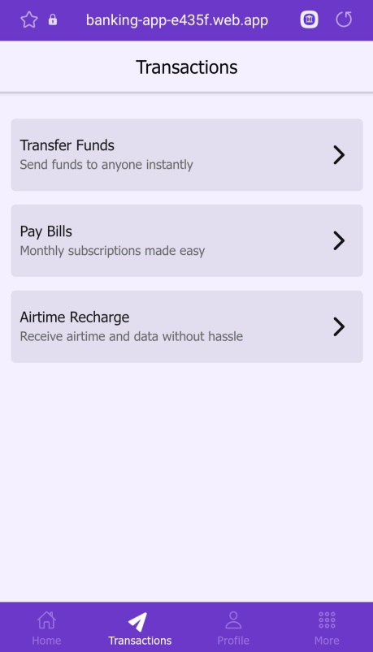 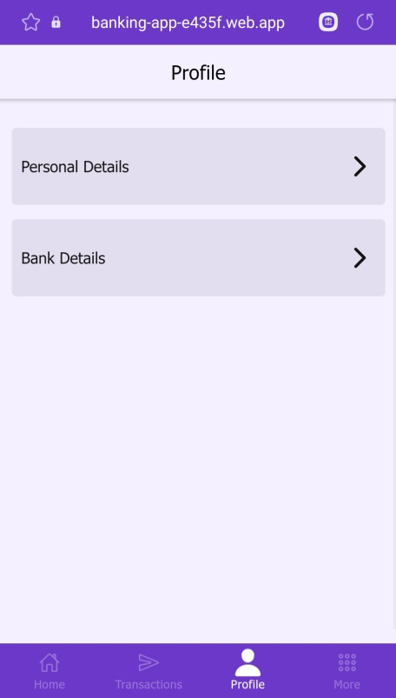 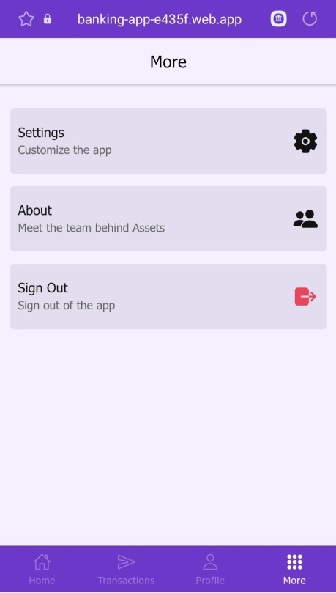

Fig. 13: The ‘Transactions’, ‘Profile’ and ‘More’ page of the Asset Banking app

**TRANSACTIONS**

The transaction page allows you to conduct various personal transactions such as transfer funds, pay bills, and pay for subscriptions.

* **TRANSFER FUNDS**

The Transfers tab enables you to quickly and easily transfer funds to other bank account. To transfer funds, follow the steps outlined below:

* Tap the transfer funds tab.
* Tap on the account number tab and provide a valid account number.
* Tap on amount and enter a transfer amount.
* Tap on bank and select the recipient bank from the Bank menu.

NOTE: The account number provided must be for the bank selected in order to avoid transfers to the wrong account.

* Tap on NEXT. This causes two more fields to display. The first field shows the recipient’s name and the other requests for either the reason for or the description of the transfer.
* After confirming the account name, tap on confirm transfer.
* If transfer is successful, a pop up will display indicating that the transaction was successful.

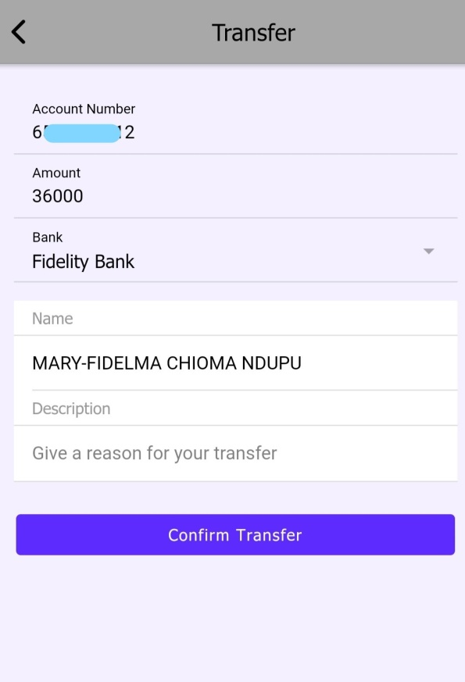

Fig. 14: The ‘Transfer’ page of the Asset Banking app during a test transfer

* **PAY BILLS / SUBSCRIPTIONS**

You can conduct basic bill payment from the convenience of your home using the Asset Mobile Banking app by tapping the “Pay Bills” tab on the Transactions page. This allows you to pay for services like DSTV subscription, Internet and so on.

To Pay Bills:

* Tap the Transactions tab at the bottom of the Home page.
* Select “Pay Bills” on the Transactions page.
* Select the category (TV, Internet, Betting or Electricity). Click OK.
* Select the Service Provider. Click OK
* Select your preferred package. Click OK.
* Click Pay.
* If successful, a pop-up will display “Payment Successful”.
* If not successful, a pop-up will display the error message. For example, it may display “Insufficient funds”.

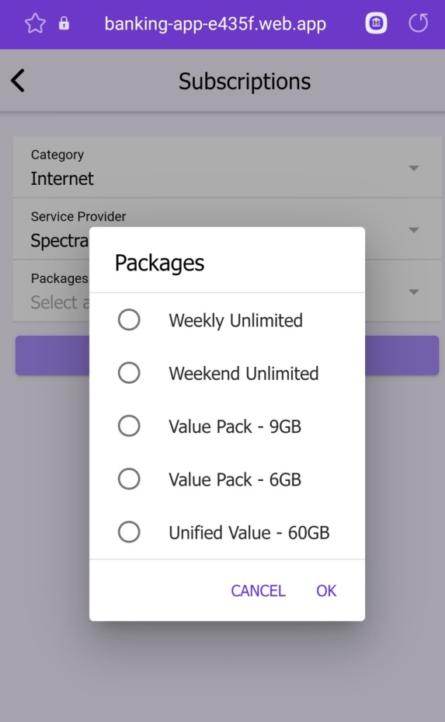

Fig. 15: The ‘Subscription’ page of the Asset Banking app during a test payment

* **AIRTIME RECHARGE**

This feature is currently not available for users. Please stay tuned for updates.

**USER PROFILE**

This is the page that displays all of the user’s personal banking details. The “Personal Details’ tab holds all of the user’s person information like their full name, phone number and email address. The “Personal Details” also allows the user to change their Asset Mobile password. The “Banking Details” tab below holds more sensitive information like the user’s account number and BVN.

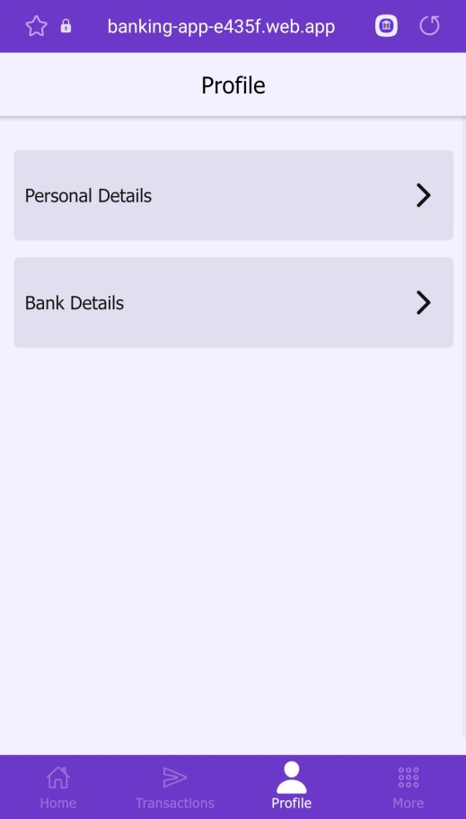

Fig. 15: The ‘Profile’ page of the Asset Banking app during a test run

**‘MORE’ TAB**

This is tab contains the ‘Settings’ page, the ‘About’ page and the Sign Out button. The ‘Settings’ page contains toggle buttons that allows the user to switch between the Light and Dark modes, and to turn the Text-To-Speech (TTS) feature on and off. The “More” page also contains a section that allows users to change their pin at will. The “About Us” page simple tells the user a bit about the team, app and why the app was built.

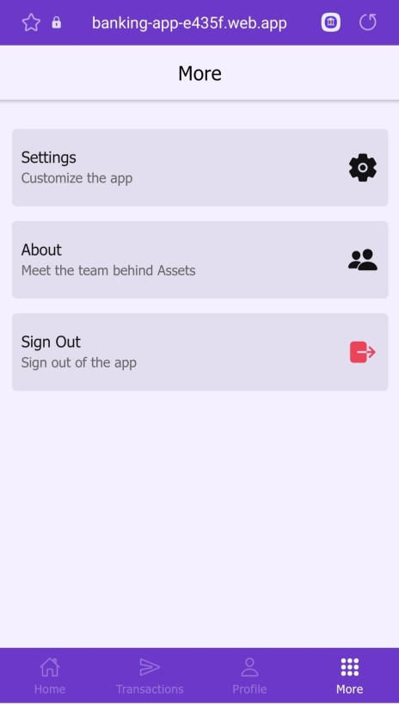 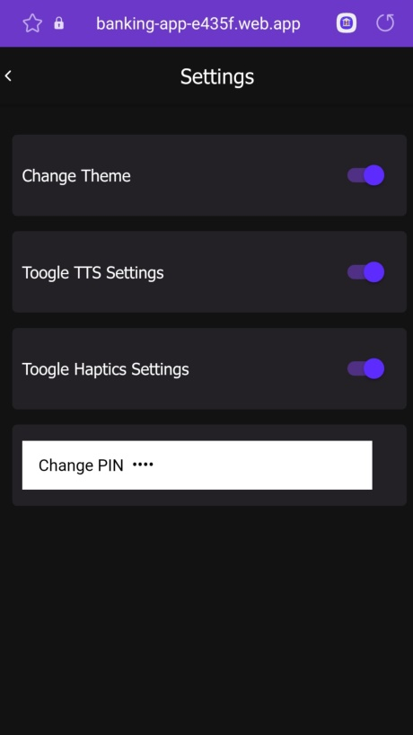 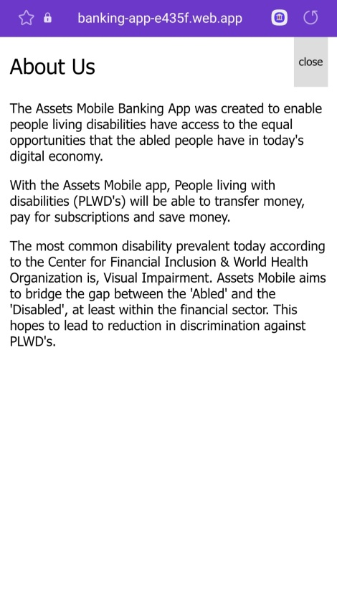

Fig. 16: The ‘More’, ‘Settings’ and ‘About’ pages of the Asset app during a test run